- (10 points) Assembly.
Take the following recursive assembly function.
The mul instruction may be new to you.
You can read about where it reads and stores values at https://en.wikibooks.org/wiki/X86_Assembly/Arithmetic
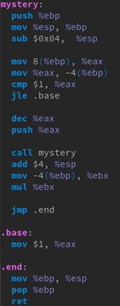
a. (5 points) What would mystery(3) be?
b. (2 points) How many local variables are used in this function? (hint: how much stack space is used?)
c. (2 points) Translate this function into an equivalent recursive C function.
d. (1 point) This function has a specific name. What is that name?

a. mystery(3) = 3*2*1 = 6

b. one local variable are used, -4(%ebp)

c.
int mystery(int num) {
if(num <= 1)
return 1;
return mystery(num -1 )* num;

}

d. Factorial

- (10 points) Scheduling.
Three batch jobs, A, B, C, arrive at a computer at time 0.
They have estimated running times of 10, 6, 2.
Two other jobs D and E arrive at time 3 with durations: 4 and 8 minutes.
For each of the following scheduling algorithms, determine the mean turnaround time.
a. (5 points) First Come, first served (run in order A, B, C, D, E).
b. (5 points) Longest job first.
a.
(10+16+18+(22-3)+(30-3))/5 = 90/5 = 18
total turnaround time: 90
average turnaround time: 18

b.
(10+ (18-3)+24+(28-3)+30)/5 = 104/5=20.8
total trunaround time: 104
average turnaround time: 20.8

- (10 points) Read the following code snippet and then answer the questions below:
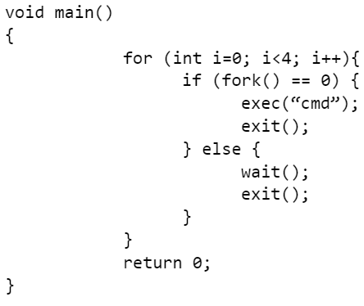
a. (5 points) How many processes (in addition to the original one) are created when this program is executed? Explain your answer.
b. (5 points) Are there any zombies created? Explain your answer.

Your Answer:
a.
There is only one child process created, and with the parent process,
there are two process in total. The parent process waits for the child
process finishing running and exit, so the whole process exits without
finishing the loop.

b.
There is no zombie created as the wait() is called by parent. So,
parent waits for the child finishing running instead of letting it
become zombie.

Question 5
- (10 points) Suppose that a (very slow) computer can read or write a memory word in 100 microseconds (1/10 of a millisecond).
Also suppose that when the timer interrupt occurs, 32 CPU registers (each one word), plus the program counter (also one word) are saved by pushing them in the stack.
a. (5 points) If the interrupt handler just acknowledges the interrupt (which takes 3.4 milliseconds) and then returns (restoring the saved CPU registers and program counter), how long does it take to handle a one timer interrupt?
b. (5 Points) Assuming the system timer ticks once every 100 milliseconds, what percentage of the system’s time is spent handling timer interrupts?

Your Answer:
time to r/w: 0.1 millisecond
cpu number: 32
register size: 1word
program counter size: 1word

a.
push register to stack = 32 * 1 * 0.1 = 3.2 millisecond
push PC value to stack = 1 * 0.1 = 0.1 millisecond
make interrupt = 3.4 millisecond
restore register and PC = 3.2 + 0.1 = 3.3 millisecond

total time = 3.2 + 0.1 + 3.4 + 3.3
= 10 millisecond = 1000microseconds

b.
percentage = 10/100 *100% = 10%

Question 6
- (10 Points) Filling the blanks, 2 points each
a. When an x86 PC boots, the first program executed is the ____________, which is stored in the motherboard.
b. The entrance to the kernel is handled by the ___________ handler.
c. The principal responsibility of the ________ is to control the execution of processes.
d. Please provide some constructive feedback on the homworks (only serious feedback will be given credit) _____________________
e. Please provide some constructive feedback on the class and/or recitations (only serious feedback will be given credit) ___________________
(Don't forget!) Pledge:
a. BIOS
b. system call
c. Process Control Block

d.
One is about anubis. It seems like it automatically grades the
assignment but cannot request a grade manually, which is really annoying
as sometimes, you need to wait for over 5 mins for only one change.
Also, I wish the test case in anubis and the one in handout can be
exactly the same or it makes misunderstanding and unneccesary time
wasting. For example, during this exam, I spent almost half an hour
to find out the little space between the dot and number. To sum up,
maybe make the example easier to understand, or give more explanation.

Another is about the difficulty curve. It seems like comparing with
hw1 and hw2, hw3 is weigh more complicated while much information
are not given. Many of my friend complain that the some hw content
does not fit what is talked in class(Something in hw never been heard
in class). I know the assignment is going to have more file to edit
which is told by one of my friends who took this class last semester.
Though I am not sure how might be the way to adjust this, I believe
it still needs to be take into consideration.

e.
Just I said, the class might associate more with the hw content
instead of giving recitation all the duty to do this as not all
of the student have the time to or willing to attend or watch the
recitation.
Also, I believe it is necessary to change the balance of each
recitation. Some recitaion takes 1-2 hours, while other takes only
15mins reading the ppt. If we can read ppt on our own, what's the
need for that recitaion?
Some extra but not necessary suggestion: as some of the recitaions
are super long, it is really inconvinent to look for one part
inside the video inside the whole range. So, maybe open the
comment system for the recording so that someone can put the
timeline with each content. Then, it will be easy to track the
things we need in the recording. The same as the class recording,
but I know it is not necessary.

pledge:
I, Cheng Pan, affirm that I have completed the exam completely on my own, without
consulting with other classmates. I have followed the required rules. I understand that violating
these rules would represent academic dishonesty.

